Project Design Phase
Solution Architecture

Date | 2-01-2026
Team ID
Project Name | TheBookStop – Online Bookstore Platform
Maximum Marks | 4 Marks

Solution Architecture
The solution architecture for TheBookStop is designed to deliver a secure, scalable, and user-friendly online bookstore platform. The architecture ensures smooth communication between users, sellers, and administrators while supporting efficient data management and system performance.
The system follows a three-tier architecture consisting of:
- Presentation Layer (Frontend)
- Application Layer (Backend / Business Logic)
- Data Layer (Database)
This structured approach enables maintainability, scalability, and high performance.
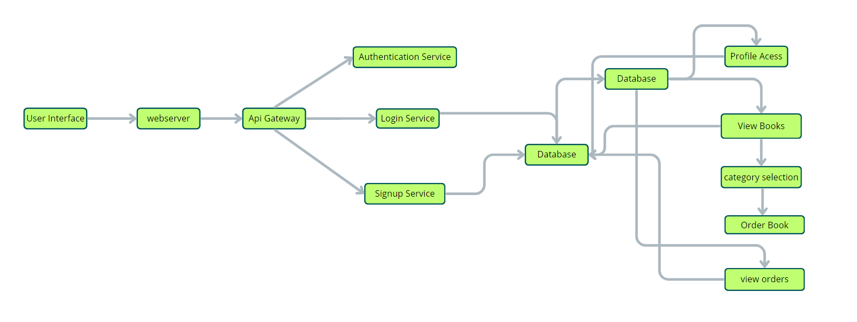

Key Architectural Features
- Seamless browsing and purchasing experience for users
- Efficient book management for sellers
- Secure authentication and role-based authorization
- Reliable order processing and transaction handling
- Real-time updates for orders, reviews, and user activities
- Scalable system design for future expansion

Architecture Components
1. Presentation Layer (Frontend)
- Developed using React.js
- Handles user interaction and UI rendering
- Communicates with backend APIs using HTTP requests
- Supports responsive design for multiple screen sizes
2. Application Layer (Backend)
- Built using Node.js and Express.js
- Handles business logic such as authentication, cart management, orders, and reviews
- Implements role-based access control (User, Seller, Admin)
- Manages secure API communication
3. Data Layer (Database)
- Uses MongoDB for storing:
  - User data
  - Book details
  - Orders and transactions
  - Reviews and ratings
- Ensures data consistency and scalability

Security & Authentication
- JWT-based authentication
- Encrypted password storage
- Role-based authorization
- Secure API access

System Workflow Overview
- User logs in or registers on the platform
- User browses books and adds them to cart or wishlist
- Orders are placed and stored securely in the database
- Sellers manage inventory and order fulfillment
- Admin monitors activity and manages users and content

Example – Solution Architecture Diagram (Conceptual)
[ User / Seller / Admin ]
|
(React Frontend)
|
REST API (Express.js)
|
Business Logic Layer
|
MongoDB Database

Final Outcome
The solution architecture of TheBookStop ensures high performance, scalability, and reliability. By adopting a modular and layered design, the system supports seamless interactions between users, sellers, and administrators while enabling future growth and feature expansion.

